Syeda Reeha Quasar

14114802719

4C7

Aim

To Draw an E-R Diagram to represent different entities, attributes and relations in a university.

Experiment - 1

DATABASE MANAGEMENT SYSTEMS LAB

# **EXPERIMENT – 1**

## **Aim:**

To Draw an E-R Diagram to represent different entities, attributes and relations in a university.

## **Theory:**

**ER Diagram** stands for Entity Relationship Diagram, also known as ERD is a diagram that displays the relationship of entity sets stored in a database. In other words, ER diagrams help to explain the logical structure of databases. ER diagrams are created based on three basic concepts: entities, attributes and relationships.

ER Diagrams contain different symbols that use rectangles to represent entities, ovals to define attributes and diamond shapes to represent relationships.

At first look, an ER diagram looks very similar to the flowchart. However, ER Diagram includes many specialized symbols, and its meanings make this model unique. The purpose of ER Diagram is to represent the entity framework infrastructure.

ER Diagram Symbols & Notations: There are three basic elements in an ER Diagram: entity, attribute, relationship. There are more elements which are based on the main elements. They are weak entity, multi-valued attribute, derived attribute, weak relationship, and recursive relationship. Cardinality and ordinality are two other notations used in ER diagrams to further define relationships.

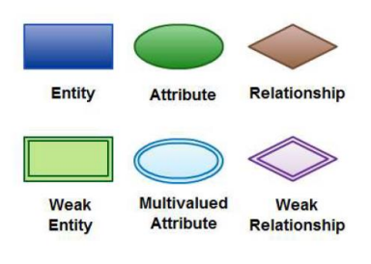

**Why use ER Diagrams?**

Here, are prime reasons for using the ER Diagram

* Helps you to define terms related to entity relationship modeling
* Provide a preview of how all your tables should connect, what fields are going to be on each table
* Helps to describe entities, attributes, relationships
* ER diagrams are translatable into relational tables which allows you to build databases quickly
* ER diagrams can be used by database designers as a blueprint for implementing data in specific software applications
* The database designer gains a better understanding of the information to be contained in the database with the help of ERP diagram
* ERD Diagram allows you to communicate with the logical structure of the database to users

**E-R Diagram**

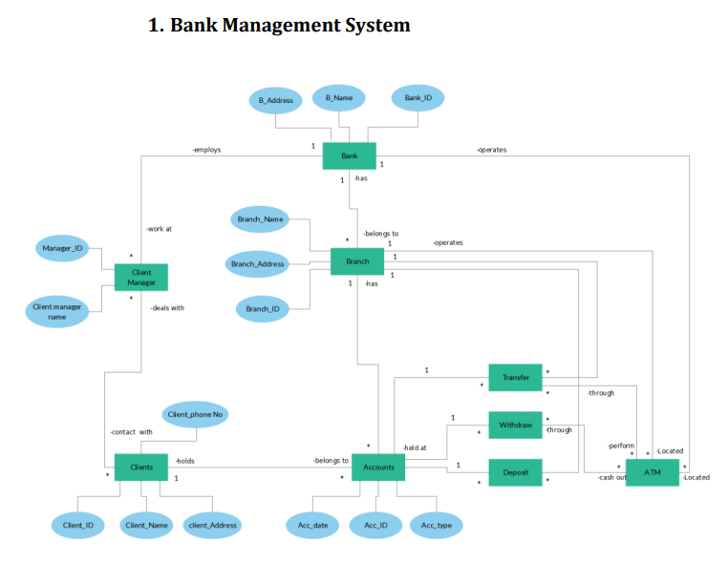

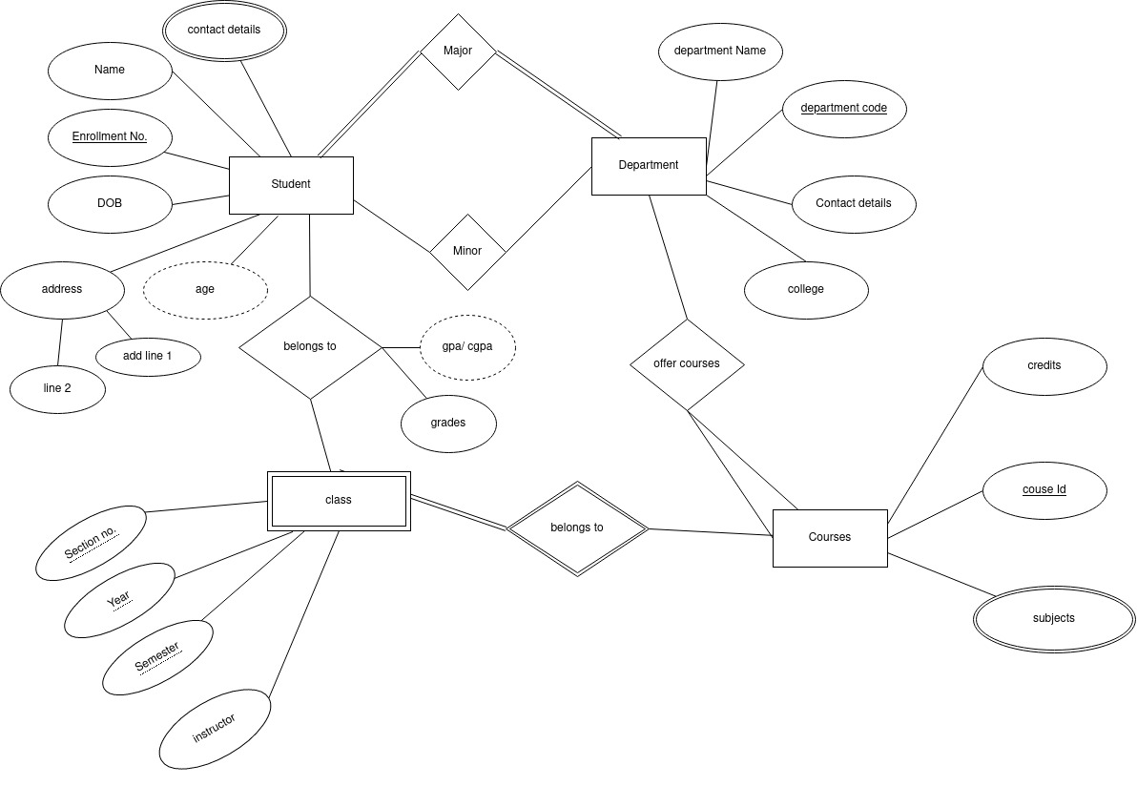

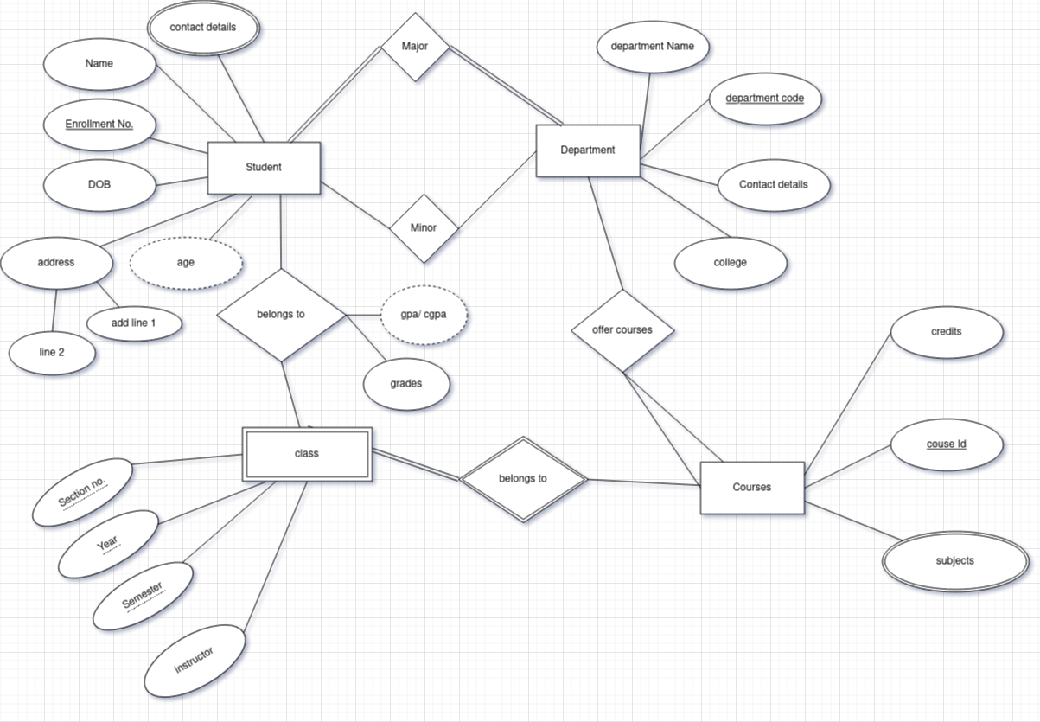

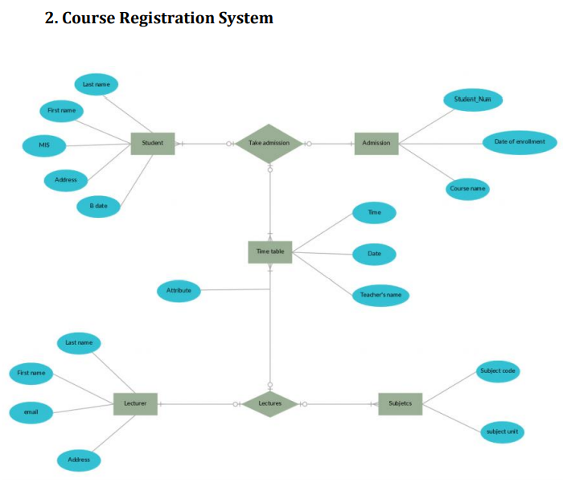

# Write advantages and disadvantages of top 5 databases

## MySQL

**Advantages –**

1.    Data Security

MySQL is globally renowned for being the most secure and reliable database management system used in popular web applications like WordPress, Drupal, Joomla, Facebook and Twitter. The data security and support for transactional processing that accompany the recent version of MySQL, can greatly benefit any business especially if it is an eCommerce business that involves frequent money transfers.

2.    On-Demand Scalability

MySQL offers unmatched scalability to facilitate the management of deeply embedded apps using a smaller footprint even in massive warehouses that stack terabytes of data. On-demand flexibility is the star feature of MySQL. This open source solution allows complete customization to eCommerce businesses with unique database server requirements.

3.    High Performance

MySQL features a distinct storage-engine framework that facilitates system administrators to configure the MySQL database server for a flawless performance. Whether it is an eCommerce website that receives a million queries every single day or a high-speed transactional processing system, MySQL is designed to meet even the most demanding applications while ensuring optimum speed, full-text indexes and unique memory caches for enhanced performance.

4.    Round-The-Clock Uptime

MySQL comes with the assurance of 24X7 uptime and offers a wide range of high availability solutions like specialized cluster servers and master/slave replication configurations.

5.    Comprehensive Transactional Support

MySQL tops the list of robust transactional database engines available on the market. With features like complete atomic, consistent, isolated, durable transaction support, multi-version transaction support, and unrestricted row-level locking, it is the go-to solution for full data integrity. It guarantees instant deadlock identification through server-enforced referential integrity.

6.    Complete Workflow Control

With the average download and installation time being less than 30 minutes, MySQL means usability from day one. Whether your platform is Linux, Microsoft, Macintosh or UNIX, MySQL is a comprehensive solution with self-management features that automate everything from space expansion and configuration to data design and database administration.

7.    The Flexibility Of Open Source

All the fears and worries that arise in an open source solution can be brought to an end with My SQL’s round-the-clock support and enterprise indemnification. The secure processing and trusted software of MySQL combine to provide effective transactions for large volume projects. It makes maintenance, debugging and upgrades fast and easy while enhancing the end-user experience.

**Disadvantages**

1. Delivering Hot Data

In large applications, the data cache stored in RAM can grow very large and be subjected to thousands or even millions of requests per second. MySQL does not have a strong memory-focused search engine. Because it is not designed for very high concurrency, users can be exposed to bottlenecks and periodic performance issues. MySQL is saddled with relatively high overhead and cannot deliver optimal speed.

2. Dealing with Highly Volatile Data

In thousands of updates per second are applied to a single database row (for example, flash online sales for high-demand concert tickets), it is crucial to maintain exact values at every second. MySQL is designed around full transactional semantics with support for long transactions and works with disk-based log durability. It is therefore not well suited for use with this kind of highly volatile data.

3. Avoid MySQL Scalability Limitations

MySQL was originally designed as a single-node system and not with the modern data center concept in mind. Today’s largest MySQL installations cannot scale by using MySQL as a single system and must rely on sharding, or splitting a data set over multiple nodes or instances. However, most sharding solutions in MySQL are manual and make application code more complex. Any performance gain is lost when queries must access data across multiple shards.

4. Providing Analytics

MySQL was not designed for running complicated queries against massive data volumes which requires crunching through a lot of data on a huge scale. MySQL optimizer is quite limited, executing a single query at a time using a single thread. A given MySQL query can neither scale among multiple CPU cores in a single system nor execute distributed queries across multiple nodes.

5. Powering Full Text Searches at Scale

MySQL can handle basic full text searches. However, because of its inability to manage parallel processing, searches do not scale well as data volumes increase.

## Oracle

**Advantages**

1.Portability

Well, the oracle database is ported to all different platforms than all other its competition. It easily runs on almost 20 networking protocols and also on more than 100 hardware platforms. The same thing makes it easy for writing an oracle application easily by make changes safely in the operating system and hardware.

2.Backup and Recovery

It is good to be used as to take a proper backup of your entire oracle online backup as well as recovery too. With the help of using oracle database, one can easily become able to make a point-in-time recovery. For the same, you have to require storage space and also archive mechanisms.  
3.High performance  
It means that making a good oracle database provides you with quite good speed and also with large databases. Also, oracle database improves the performance and speed of consideration with transaction control and locking.

4.Multiple Database Support

The best advantage which users get when they make use of the oracle database is that it easily manages the multiple databases within the same transaction. The same thing is best applicable, or you can say implemented in V7.

So, all these are the best benefits which all the users of oracle database get when they make its use. To gather more information about the same process and to know how to make appropriate use of the oracle database, one should check out more and more reviews. The more reviews you go through when going to make use of the oracle database, the easier it becomes for you to get good results by using the same database.

5.Versions Changes

Oracle keeps you informed about the next major release for any potential changes so you can get prepared. It offers you good backward compatibility by which you will no longer be required to re-write an application while upgrading the DBMS. Many have worked with Oracle since V4 Beta and have never faced any unpleasant experiences in terms of syntax.

**Disadvantages**

1.Complexity

One of the biggest disadvantages of Oracle Database is its complexity. It is not preferable to use Oracle, especially when the users are not technically sound and lack the technical ability that is needed in order to work with the Oracle Database. Further, it is also not advisable to use Oracle if the company or an individual is seeking a database that is easy to use and contains basic features. It is not as simple as installing Oracle and get started, rather it requires specialized skills to install and maintain as it is an incredibly complex engine.

2.Cost of Oracle Database

The price of Oracle products can increase up to ten times compared to the [MS SQL Server](https://en.wikipedia.org/wiki/Microsoft_SQL_Server) Database Solution for a mid-range solution. Hence, people are tended to go with other options that are comparatively cheaper, say, for example, you can install MySQL for free or utilize any one of several engines in a solution like AWS by investing a very nominal amount.

3.Difficult to Manage

Oracle is generally a lot more complex and difficult in terms of the management of certain activities. Hence, the pro tip here is to install a basic version and then perform configuration with minimal customization. Oracle Database is only useful when you need large size databases. The use of Oracle in small or medium-sized companies is not preferable where small databases are needed. In such a scenario, the best option would be MySQL, which is more cost-effective.

## PostgreSQL

**Advantages**

1. PostgreSQL can run dynamic websites and web apps as a LAMP stack option
2. PostgreSQL's write-ahead logging makes it a highly fault-tolerant database
3. PostgreSQL source code is freely available under an open source license. This allows you the freedom to use, modify, and implement it as per your business needs.
4. PostgreSQL supports geographic objects so you can use it for location-based services and geographic information systems
5. PostgreSQL supports geographic objects so it can be used as a geospatial data store for location-based services and geographic information systems
6. To learn Postgres, you don't need much training as its easy to use
7. Low maintenance and administration for both embedded and enterprise use of PostgreSQL

**Disadvantages-**

1. Postgres is not owned by one organization. So, it has had trouble getting its name out there despite being fully featured and comparable to other DBMS systems
2. Changes made for speed improvement requires more work than MySQL as PostgreSQL focuses on compatibility
3. Many open source apps support MySQL, but may not support PostgreSQL
4. On performance metrics, it is slower than MySQL.

## Cassendra

**Advantages:**

1.Open Source

Cassandra is Apache’s open-source project, this means it is available for FREE! Yes, you can download the application and use the way you want. Infact, its open-source nature has given birth to a huge Cassandra community where like-minded people share their views, queries, suggestions related to Big Data. Further, Cassandra can be integrated with other Apache open-source projects like Hadoop (with the help of MapReduce), Apache Pig and Apache Hive.

2.   Peer to Peer Architecture:

Cassandra follows a peer-to-peer architecture, instead of master-slave architecture. Hence, there is no single point of failure in Cassandra. Moreover, any number of servers/nodes can be added to any Cassandra cluster in any of the datacenters. As all the machines are at equal level, any server can entertain request from any client. Undoubtedly, with its robust architecture and exceptional characteristics, Cassandra has raised the bar far above than other databases.

3.   Elastic Scalability:

One of the biggest advantages of using Cassandra is its elastic scalability. Cassandra cluster can be easily scaled-up or scaled-down. Interestingly, any number of nodes can be added or deleted in Cassandra cluster without much disturbance. You don’t have to restart the cluster or change queries related Cassandra application while scaling up or down. This is why Cassandra is popular of having a very high throughput for the highest number of nodes. As scaling happens, read and write throughput both increase simultaneously with zero downtime or any pause to the applications.

4.   High Availability and Fault Tolerance:

Another striking feature of Cassandra is Data replication which makes Cassandra highly available and fault-tolerant. Replication means each data is stored at more than one location. This is because, even if one node fails, the user should be able to retrieve the data with ease from another location. In a Cassandra cluster, each row is replicated based on the row key. You can set the number of replicas you want to create. Just like scaling, data replication can also happen across multiple data centres. This further leads to high level back-up and recovery competencies in Cassandra.

*5.   High Performance:*

The basic idea behind developing Cassandra was to harness the hidden capabilities of several multicore machines. Cassandra has made this dream come true! Cassandra has demonstrated brilliant performance under large sets of data. Thus, Cassandra is loved by those organizations that deal with huge amount of data every day and at the same time cannot afford to lose such data.

*6.   Column Oriented:*

Cassandra has a very high-level data model – this is column-oriented. It means, Cassandra stores columns based on the column names, leading to very quick slicing. Unlike traditional databases, where column names only consist of metadata, in Cassandra column names can also consist of the actual data. Thus, Cassandra rows can consist of masses of columns, in contrast to a relational database that consists of a few number of columns. Cassandra is endowed with a rich data model.

7.   Schema-Free

Since its creation, Cassandra is famous for being a Schema-less/schema-free database in its column family. In Cassandra, columns can be created at your will within the rows. Cassandra data model is also famously known as a schema-optional data model. In contrast to a traditional database, in Cassandra there is no need to show all the columns needed by your application at the surface as each row is not expected to have the same set of columns.

It is because of the above reasons, Cassandra is in great demand among several companies, where MySQL is getting replaced by NoSQL databases. A database that was initially created to solve the inbox search issues at Facebook, has come a long way to solve Big Data problems. Today, Cassandra is used in diverse applications…whether it is streaming videos or supporting various business units or production applications

**Disadvantages:**

1. Replication means data gets replicated across multiple nodes as you configure. For ex, every record I write I can have it replicated to 2 or 3 or even 10 other nodes. But this also means any bad data also gets replicated. So you have to take care to not do so.
2. Repairs - This is Cassandra specific concept and is not so trivial to understand, let alone master. Most users leave it to the database. (This is when some nodes die but don’t come back up within a window that allows other nodes to pass on the data that the node missed.
3. You cannot run unanticipated queries because the data storage on disk or in mem is such that you can’t query on any column you want. You will explicitly have to add indexes. This will bite you if you simply assume that you just have to create a table using CQL (Cassandra Query Language) which is modeled on SQL.

## MongoDB

**Advantages**

There are many great features inbuilt with MongoDB. As compared to RDBMS, so let’s discuss MongoDB Benefits.

1. Flexible Database

We know that MongoDB is a schema-less database. That means we can have any type of data in a separate document. This thing gives us flexibility and a freedom to store data of different types.

2. Sharding

We can store a large data by distributing it to several servers connected to the application. If a server cannot handle such a  big data then there will be no failure condition. The term we can use here is “auto-sharding”.

3. High Speed

MongoDB is a document-oriented database. It is easy to access documents by indexing. Hence, it provides fast query response. The speed of MongoDB is 100 times faster than the relational database.

4. High Availability

MongoDB has features like replication and gridFS. These features help to increase data availability in MongoDB. Hence the performance is very high.

5. Scalability

A great advantage of MongoDB is that it is a horizontally scalable database. When you have to handle a large data, you can distribute it to several machines.

**Disadvantages -**

1. Joins not Supported

MongoDB doesn’t support joins like a relational database. Yet one can use joins functionality by adding by coding it manually. But it may slow execution and affect performance.

2. High Memory Usage

MongoDB stores key names for each value pairs. Also, due to no functionality of joins, there is data redundancy. This results in increasing unnecessary usage of memory.

3. Limited Data Size

You can have document size, not more than 16MB.